Recall the dataset HighPeaks. Forty-six mountains in the Adirondacks of upstate New York are known as the High Peaks with elevations near or above 4000 feet. The variables include Elevation (in feet) of each peak, Difficulty rating (on a 2 to 7 scale with 7 being the most difficult), the Ascent (in feet), Length of a round trip distance (in miles), and expected trip Time (in hours). There is also a binary variable, HiDifficulty, which equals 1 if the difficulty level is 5 or above (and equals 0 if for difficulty levels of 4 or below).
> head(HighPeaks)
Peak Elevation Difficulty Ascent Length Time HiDifficulty
1 Mt. Marcy 5344 5 3166 14.8 10.0 1
2 Algonquin Peak 5114 5 2936 9.6 9.0 1
3 Mt. Haystack 4960 7 3570 17.8 12.0 1
4 Mt. Skylight 4926 7 4265 17.9 15.0 1
5 Whiteface Mtn. 4867 4 2535 10.4 8.5 0

- Below is R output from a linear regression model of Y = Time on X = Ascent; relevant plots are on Page 2.
> summary(time.lm)
Call:
lm(formula = Time ~ Ascent, data = HighPeaks)

Residuals:
Min 1Q Median 3Q Max
-4.327 -2.075 -0.150 1.414 6.529

Coefficients:
Estimate Std. Error t value Pr(>|t|)
(Intercept) 4.2100541 1.8661683 2.256 0.02909 *
Ascent 0.0020805 0.0005909 3.521 0.00101 **
---
Signif. codes: 0 ‘***’ 0.001 ‘**’ 0.01 ‘*’ 0.05 ‘.’ 0.1 ‘ ’ 1

Residual standard error: 2.496 on 44 degrees of freedom
Multiple R-squared: 0.2198, Adjusted R-squared: 0.2021
F-statistic: 12.4 on 1 and 44 DF, p-value: 0.001014

> anova(time.lm)
Analysis of Variance Table

Response: Time
Df Sum Sq Mean Sq F value Pr(>F)
Ascent 1 77.261 77.261 12.399 0.001014 **
Residuals 44 274.174 6.231
---
Signif. codes: 0 ‘***’ 0.001 ‘**’ 0.01 ‘*’ 0.05 ‘.’ 0.1 ‘ ’ 1

> predict.lm(time.lm, newdata=data.frame(Ascent=3000),interval="confidence")
fit lwr upr
1 10.45163 9.701043 11.20222
> predict.lm(time.lm, newdata=data.frame(Ascent=3000),interval="prediction")
fit lwr upr
1 10.45163 5.365099 15.53816

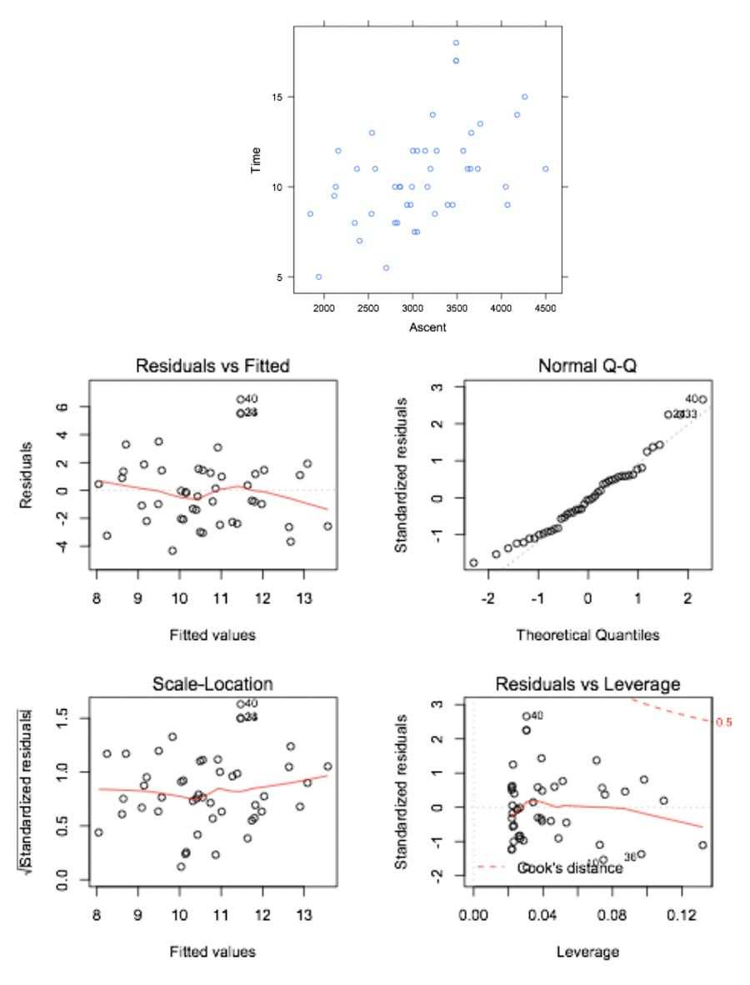
- What is the fitted regression model?
Time = 4.2101 + 0.0021(Ascent)
- Interpret the slope of the model in context.

For every 1-foot increase in Ascent the expected Time increases by 0.002 hours (7.2 seconds).

- Are there any outliers in this situation? Identify these points and explain what leads you to believe they are outliers.

Yes, the residual plots flag three points as potential outliers: #40, 24, 33. These points all have standardized residuals greater than 2, meaning they lie pretty far from the regression line.

- Are there any influential points in this situation? Identify these points and explain what leads you to believe they are influential.

According to the Cook’s distance plot, there are no influential points since none of the points have
Cooks D > 0.5.

- Interpret the 95% prediction interval for trip time when Ascent is 3000 feet.

For a particular peak with a 3000-foot ascent, we are 95% confident that the trip time will be between 5.365 hours (5 hrs, 22 min) and 15.538 hours (15 hrs, 32 min).

(e) Test the null hypothesis that there is not a linear relationship between Ascent and Time. Make sure you include all the steps of the appropriate hypothesis test!

H0: no linear relationship between Time and Ascent
Ha: significant linear relationship between Time and Ascent

Conditions/Assumptions: Is the linear model appropriate?
--> According to the diagnostic plots, I say yes. The residual vs. fitted plot shows random scatter and constant variance. There are a few outliers, as mentioned in part (c), but they do not appear to be influential. The normal QQ plot shows some departure from normality in the tails, but is acceptable overall.

F-stat (from ANOVA table) = 12.399 p-value = 0.001014 (Could also use test of slope; same p-value)

Since the p-value is very small, we are justified in rejecting H0 and concluding that there is a significant linear relationship between Time and Ascent.

2. Robert wants to see if there is a significant difference in mean Elevation for the hikes of different Difficulty. He isn’t sure the right way to handle the “Difficulty” variable, so he tries two different methods (shown below).
Which is the appropriate method for Robert to use? Give a justification for your choice.
> elevation.lm <- lm(Elevation~Difficulty, data=HighPeaks) #Method 1
> summary(elevation.lm)
Call:
lm(formula = Elevation ~ Difficulty, data = HighPeaks)

Residuals:
Min 1Q Median 3Q Max
-611.44 -263.08 -51.44 261.74 951.37

Coefficients:
Estimate Std. Error t value Pr(>|t|)
(Intercept) 4198.55 248.63 16.887 <2e-16 ***
Difficulty 38.82 45.61 0.851 0.399

Residual standard error: 359.4 on 44 degrees of freedom
Multiple R-squared: 0.01619, Adjusted R-squared: -0.006165
F-statistic: 0.7243 on 1 and 44 DF, p-value: 0.3994

> elevation2.lm <- lm(Elevation~as.factor(Difficulty), data=HighPeaks) #Method 2
> summary(elevation2.lm)

Call:
lm(formula = Elevation ~ as.factor(Difficulty), data = HighPeaks)

Residuals:
Min 1Q Median 3Q Max
-558.93 -211.05 -70.08 180.96 765.07

Coefficients:
Estimate Std. Error t value Pr(>|t|)
(Intercept) 4098.0 341.4 12.005 7.72e-15 ***
as.factor(Difficulty)3 -39.0 482.8 -0.081 0.936
as.factor(Difficulty)4 218.2 359.8 0.606 0.548
as.factor(Difficulty)5 480.9 353.3 1.361 0.181
as.factor(Difficulty)6 157.5 354.2 0.445 0.659
as.factor(Difficulty)7 428.6 362.1 1.184 0.243

Residual standard error: 341.4 on 40 degrees of freedom
Multiple R-squared: 0.1933, Adjusted R-squared: 0.09251
F-statistic: 1.917 on 5 and 40 DF, p-value: 0.1129
Method #2 is correct. Even though Difficulty is presented as a number, it is a categorical variable, with the numbers standing in for categories (2=easiest, 3=easy, 4=medium, etc.). Thus, we can not treat Difficulty as a numerical variable.

3. Below are the residual plots from the multiple linear regression model of Y = Time on X₁ = Elevation and
X₂ = Length; R output is on Page 6.
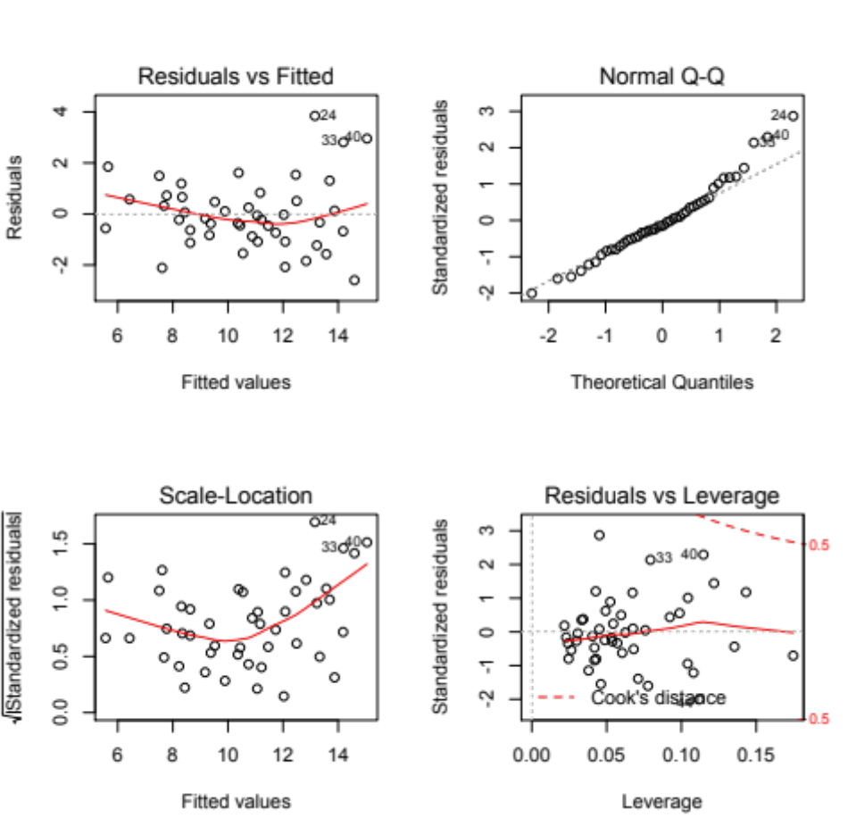
Figure 1: Residual plots for regression of Time on Elevation and Length

        - Are the conditions for inference met in this case? Make sure you discuss all conditions.

- normality of residuals -- QQ plot of residuals is follows the dotted line very well!
- constant variance & zero mean -- resids vs. fits plot looks good. The plot doesn’t show any trends and looks like a random cloud of points.
- representative – Definitely not a random sample. This is a census of all peaks above 4000 ft in the Adirondacks. Can we think of this group as representative of all peaks above 4000 ft in the US? Probably not.
- independence -- probably OK, since one mountain’s height/hike time/difficulty shouldn’t be related to another mountain’s.

Call:
lm(formula = Time ~ Elevation + Length, data = HighPeaks)

Residuals:
Min 1Q Median 3Q Max
-2.5924 -0.8050 -0.1959 0.6380 3.8432

Coefficients:
Estimate Std. Error t value Pr(>|t|)
(Intercept) 8.0753787 2.5327132 3.188 0.00267 **
Elevation -0.0014483 0.0005805 -2.495 0.01653 *
Length 0.7123344 0.0593330 12.006 2.54e-15 ***
---
Signif. codes: 0 ‘***’ 0.001 ‘**’ 0.01 ‘*’ 0.05 ‘.’ 0.1 ‘ ’ 1

Residual standard error: 1.37 on 43 degrees of freedom
Multiple R-squared: 0.7703, Adjusted R-squared: 0.7596
F-statistic: 72.09 on 2 and 43 DF, p-value: 1.844e-14

        - Is Elevation a significant variable in this model? Conduct an appropriate test (assume the conditions are met).

H₀: β₁ = 0 H_{a}: β₁ ≠ 0, where β₁ is the coefficient on Elevation.

From the output, t = -2.495 and p-value = 0.01653

So we have strong evidence that Elevation is a useful predictor of Time.

        - Is this two-predictor linear model useful for predicting Time? Explain.

Yes, because the overall F-test has F = 72.09 and p-value < 2 x 10⁻¹⁴. So we can conclude that the model is useful overall in predicting Time.

        - Explain the probabilistic meaning of the Intercept p-value (=0.00267) in the context of this situation.

Assuming the intercept is actually 0, the probability of seeing a sample with an intercept as or more extreme than 8.0753 (|intercept| ≥ 8.0753), just by chance, is 0.27%.

- Consider a multiple regression model using only Length and HiDifficulty to predict Time.
a. An ecologist for the NY Dept. of Natural Resources believes that the line relating Length and Time for the low-difficulty mountains will be parallel to the line for high-difficulty mountains. Write down the model appropriate for his belief (that is, the theoretical model; since you have no output, you can’t write down the fitted model).

Time = β₀ + β₁(Length) + β₂(HiDifficulty) + ε

- You explain to the ecologist that the line relating Length and Time for the low-difficulty mountains may be completely different than the line for high-difficulty mountains (that is, not necessarily parallel). Write down the model appropriate for your belief.

Time = β₀ + β₁(Length) + β₂(HiDifficulty) + β₃(Length * HiDifficulty) + ε

- Using the model in part (a), the expected increase in time to climb the mountain when hike length is increased by one mile is ____ β₁_____ for low-difficulty mountains and _____ β₁____ for high-difficulty mountains. (Again, since you don’t have any values, just write the appropriate symbols in the spaces above.)

- Using the model in part (b), the expected increase in time to climb the mountain when hike length is increased by one mile is ____ β₁_____ for low-difficulty mountains and ____ β₁+ β₃___ for high-difficulty mountains. (Just write the appropriate symbols in the spaces above.)

Disclaimer: The problems contained in this practice test are not an exhaustive list of all possible problems that may appear on the test. Furthermore, every problem on this review may not appear on the test. Students are expected to study material beyond just this review.

